Parent Access Registration/Login

**Registering you child in a Conroe ISD school does NOT give you a Parent Access account (PAC). If your Email address is not recognized, this means your Do NOT have a PAC account.
Parent Access Center is a free program available to all CISD parent/guardians that allows viewing of helpful information regarding; student attendance, report cards, progress reports, daily grades, state test results, Students Achieving Excellence (SAE), discipline and available lunch money. Parents may also sign up to receive an email alert when an assignment score is inputted or updated.

To register for a PAC account, go to the Conroe ISD Home Page, (conroeisd.net), click on Parents/Students, Parent Access Center and click REGISTER. Fill in the Top & Bottom sections, Do Not leave anything blank.
**All information MUST match what we have in your child’s school registration information including email address.
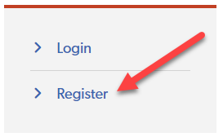
Once your information is saved, and you see the confirmation that all entries have been submitted successfully, you will receive an email with a computer generated Password.
IMPORTANT** You MUST fill in one Registration form for each of your children. Use the same Email address for each PAC account, which will link them once the other accounts are created. That email address MUST be listed in their school information.

**You can now go back to the LOGIN link on the CISD Parent Access page, use your email address and the Password you were sent, and you’re in!

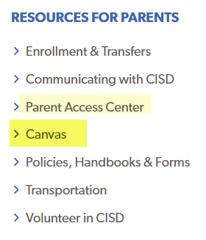
NOTE** Your PAC email and Password is also your Login for Parent Canvas, as long as you are listed as the “Primary” email in your child’s school registration information. If both parents wish to have Parents Canvas access, please speak to your schools Registrar to separate you into Parents Guardian 1 & 2.

